25 January 2007 4437 Immediate

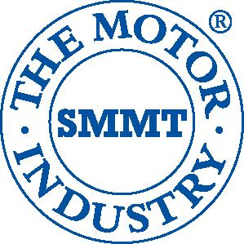
Vehicle production – December 2006

Source: | Cars |  | Commercial Vehicles |  | Total vehicles
SMMT Ltd | Dec-06 | YTD 2006 | Dec-06 | YTD 2006 | Dec-06 | YTD 2006
Total | 84,762 | 1,442,085 | 14,959 | 207,704 | 99,721 | 1,649,789
 | -11.1% | -9.7% | 10.3% | 0.5% | -8.4% | -8.5%
Export | 65,917 | 1,106,093 | 9,813 | 136,219 | 75,730 | 1,242,312
 | -15.4% | -6.7% | -4.7% | 4.6% | -17.4% | -5.6%
% of total | 77.8% | 76.7% | 65.6% | 65.6% | 75.9% | 75.3%
Home | 18,845 | 335,992 | 5,146 | 71,485 | 23,991 | 407,477
 | 8.2% | -18.3% | 58.0% | -6.5% | 16.1% | -16.5%
% of total | 22.2% | 23.3% | 34.4% | 34.4% | 24.1% | 24.7%

Car production

'As host to eight volume car manufacturers and more specialist car makers than any other European country, the UK remains a key supplier to world demand,' said Christopher Macgowan, SMMT chief executive. 'However, although in 2006 we saw increased investment in the British motor industry by some global motor giants, it was not enough to offset the impact of continued restructuring across the production base.'

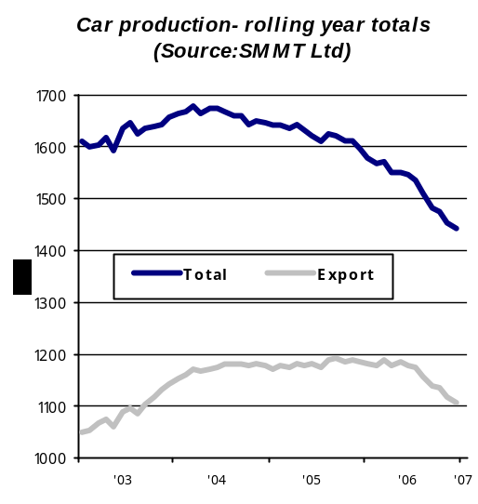

Commercial vehicle production

'Production of commercial vehicles in the UK increased slightly in 2006 – with an increase in exports driving growth,' said Christopher Macgowan, SMMT chief executive. 'Heavy commercials slowed but the market remains stable with van output staying buoyant due to sustained demand for light commercial vehicles in Europe.'
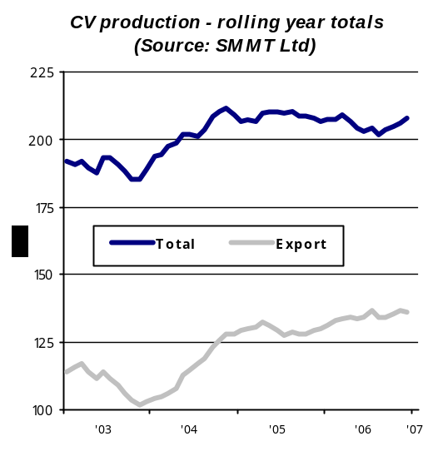`

UK Vehicle Production

PASSENGER CARS COMMERCIAL VEHICLES
 | Total | For Home | For Export | Total | For Home | For Export
1986 | 1,018,962 | 831,406 | 187,556 | 228,685 | 178,909 | 49,776
1987 | 1,142,985 | 916,486 | 226,499 | 246,727 | 185,991 | 60,736
1988 | 1,226,835 | 1,012,965 | 213,870 | 318,013 | 233,581 | 84,432
1989 | 1,299,082 | 1,018,353 | 280,729 | 326,590 | 231,087 | 95,503
1990 | 1,295,611 | 889,841 | 405,770 | 270,346 | 174,639 | 95,707
1991 | 1,236,900 | 631,515 | 605,385 | 217,141 | 108,052 | 109,089
1992 | 1,291,880 | 702,590 | 589,290 | 248,453 | 120,777 | 127,676
1993 | 1,375,524 | 842,648 | 532,876 | 193,467 | 102,320 | 91,147
1994 | 1,466,823 | 848,142 | 618,681 | 227,815 | 132,270 | 95,545
1995 | 1,532,084 | 787,473 | 744,611 | 233,001 | 140,624 | 92,377
1996 | 1,686,134 | 777,922 | 908,212 | 238,314 | 125,830 | 112,484
1997 | 1,711,923 | 738,494 | 973,429 | 223,784 | 131,900 | 91,884
1998 | 1,760,697 | 729,217 | 1,031,480 | 214,940 | 122,852 | 92,088
1999 | 1,799,004 | 649,279 | 1,149,725 | 173,537 | 109,863 | 63,674
2000 | 1,641,452 | 578,462 | 1,062,990 | 172,442 | 96,261 | 76,181
2001 | 1,492,365 | 598,151 | 894,214 | 192,873 | 96,649 | 96,224
2002 | 1,629,934 | 582,266 | 1,047,668 | 191,267 | 77,032 | 114,235
2003 | 1,657,558 | 513,798 | 1,143,760 | 188,871 | 85,954 | 102,917
2004 | 1,647,246 | 467,160 | 1,180,086 | 209,293 | 81,186 | 128,107
2005 | 1,596,356 | 411,245 | 1,185,111 | 206,753 | 76,480 | 130,273
2006 | 1,442,085 | 335,992 | 1,106,093 | 207,704 | 71,485 | 136,219
Source: SMMT

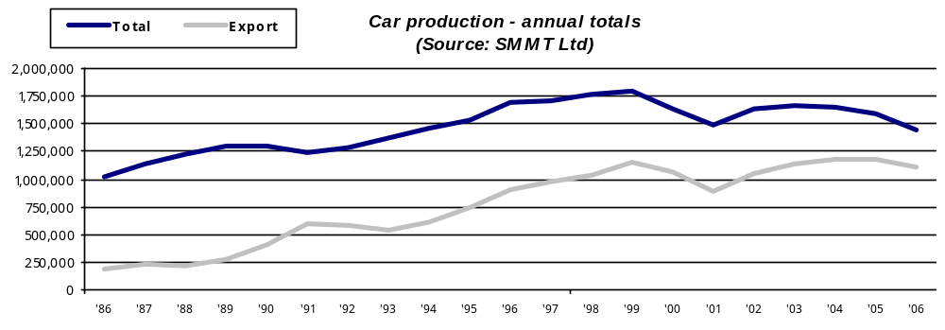
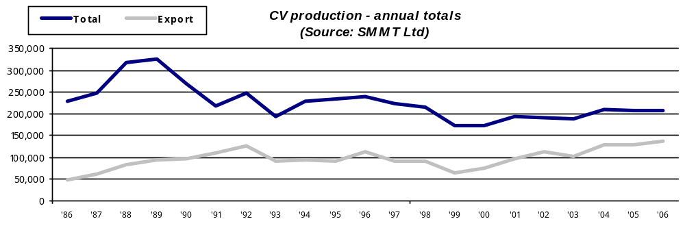
Vehicle production - December 2006

Profile: General Motors Manufacturing Ellesmere Port (GMMEP)
General Motors Manufacturing  North Road Industrial Estate  Ellesmere Port  South Wirral  CH65 1AL  Switchboard: 0151 350 2543 |  | 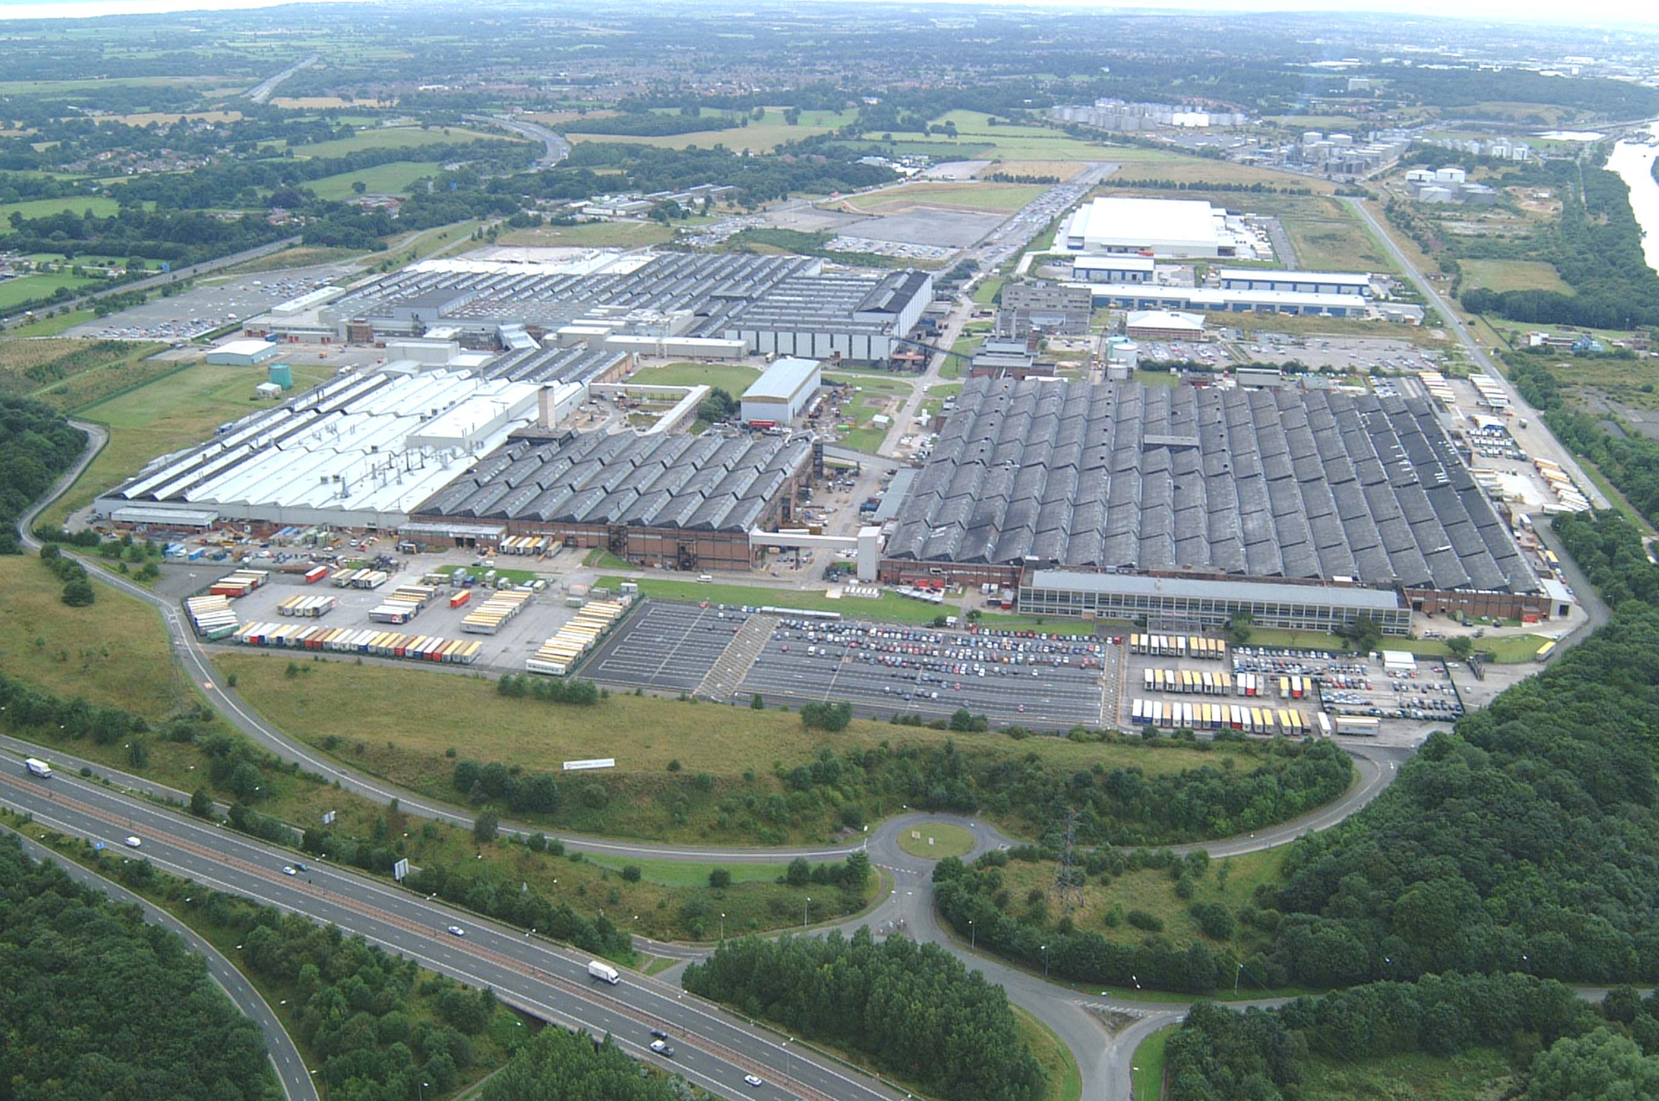
Plant Statistics:
Employees: 2222 consisting of 1990 hourly and 232 staff
Plant size: 440 acres – Close to Chester (7 miles) and Liverpool (18 miles)
Accreditations held: Investors in People since 1992. ISO 9001 since 1994 (first plant to achieve this worldwide). ISO 14001 since 1995
Models currently in production: Five door hatch-back (RHD & LHD) and Astra Van
Production Facts

Recent Major Investment
1992 £193m for V6 engine plant
1996 £300m for fourth generation Astra
2000 £189m over all UK sites
2001 £200m for launch of new Vectra
2003 £80m for fifth generation Astra
2006 £19m for introduction of Astra Van
2006 £17m for AA Tandem line – Press Shop
2006 Application submitted for next generation Astra

- Part of General Motors Worldwide organisation
- Production runs on days and nightshifts, also afternoons in Press Shop
- Capability of 43 vehicles per hour
- Capacity of 190,000 vehicles per year on three shifts
- Total production of over 147,000 vehicles during 2006
- Total production of over 4,000,000 vehicles since plant established
- Production of 338,000 commercial vehicles

Plant History
1962 Plant established
1963 Produced HA, HB and HC Viva
1970s Produced Chevette
1980s First generation Astra
1992 V6 engine plant opened
1998 Introduced third car assembly shift
2002 40th anniversary of plant
2002 Launch of new Vectra
2002 Engine plant ceased production
2004 Launch of fifth generation Astra
2006 Launch of new Astravan
2006 Transitioned to two shift operation
2008 General Motors celebrate 100th anniversary
Facts and Figure 2006:
- No Lost Work Day Cases (LWDC) in 2006. If this continues, by March 2007 will have achieved 10,000,000 hours without a LWDC
- The UK is GM’s fourth largest national market globally and largest in Europe
- Astra sales secured second place amongst compact cars in total Europe, ahead of Focus, in 2006
- Awarded Chairman’s Honours award in 2006
- Improved recycling, with 18.5 per cent less waste going to landfill sites
- Overall energy usage reduced by 19 per cent
- £7.5m spent on improving facilities at the site during 2006
Press Contacts:  Joe Jacuzzi, Communications Director  joe.jacuzzi@uk.gm.com  01582 427 620 | Tom Barnard, Press Office Manager UK  tom.barnard@uk.gm.com  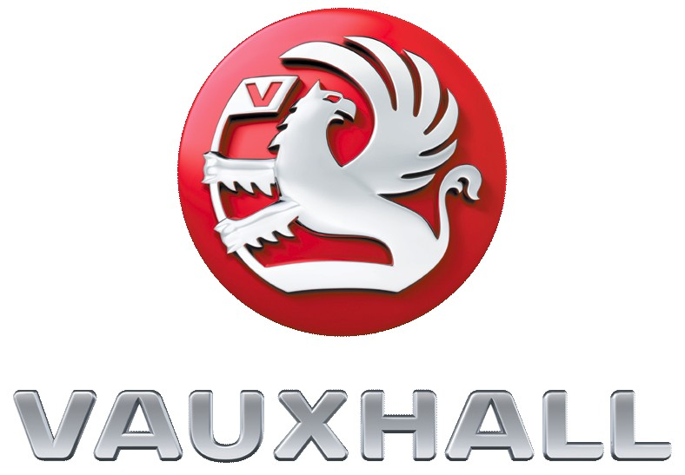  01582 427 606
  

